# Project Name

# Name- Project on E-learning GM

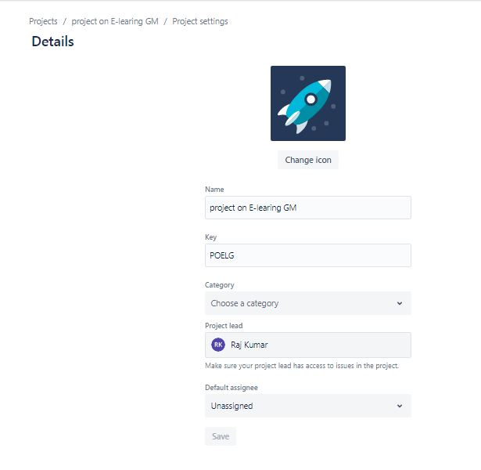

# Sprints

## Sprint 1- Registration

## C:\Users\applecom\Desktop\moolyaa\jeera screenshots\case study on jeera\Capture3.JPGSprint 2- Send a Mail

# Kanban

* **TO Do phase- where we will work**
* **Develop – Developing the software**
* **Test – Testing the software**
* 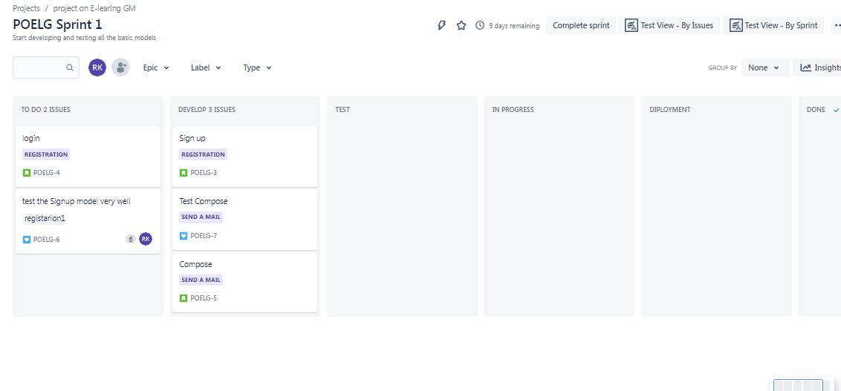**Deployment – Deploying the Product**

# Pluging in with Zephyr Squad

## Add a Test

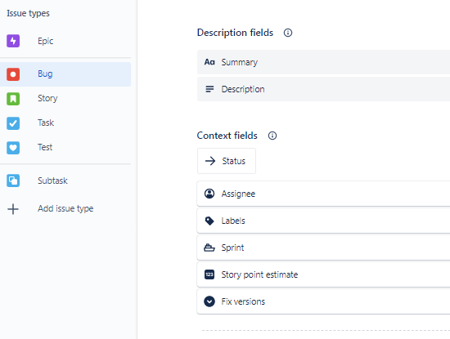

# 

# C:\Users\applecom\Desktop\moolyaa\jeera screenshots\case study on jeera\Capture5.JPGAdd New Test Cycles

# C:\Users\applecom\Desktop\moolyaa\jeera screenshots\case study on jeera\Capture6.JPGClick on Test & Task

## C:\Users\applecom\Desktop\moolyaa\jeera screenshots\case study on jeera\Capture7.JPGAdd Test Cases

# C:\Users\applecom\Desktop\moolyaa\jeera screenshots\case study on jeera\Capture10.JPGC:\Users\applecom\Desktop\moolyaa\jeera screenshots\case study on jeera\Capture11.JPGTest Execution

# Creating Issues

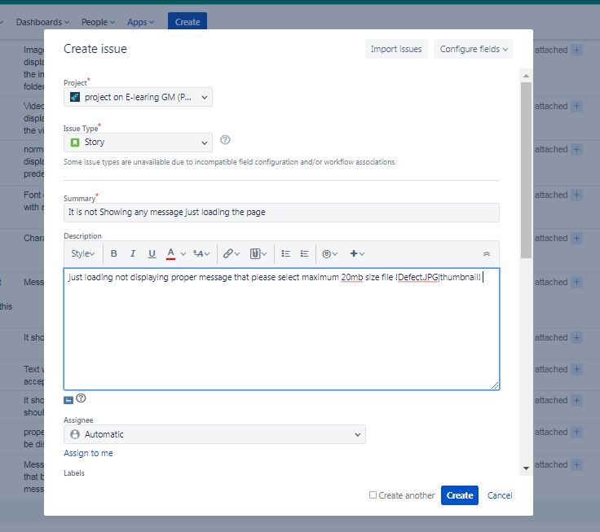

# C:\Users\applecom\Desktop\moolyaa\jeera screenshots\case study on jeera\test execution for copose.JPGTEST EXECUTION ON COMPOSE

# RELEASE

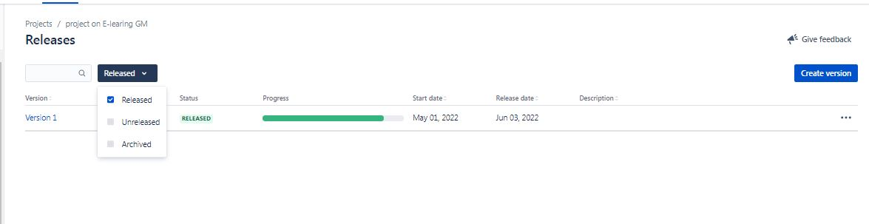

## EXECUTION REPORT

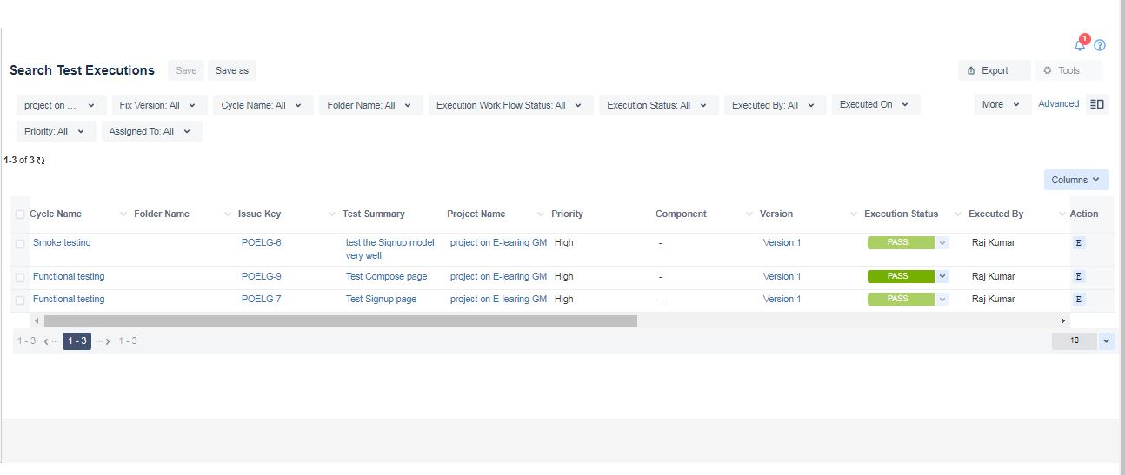

# TEST MATRIC

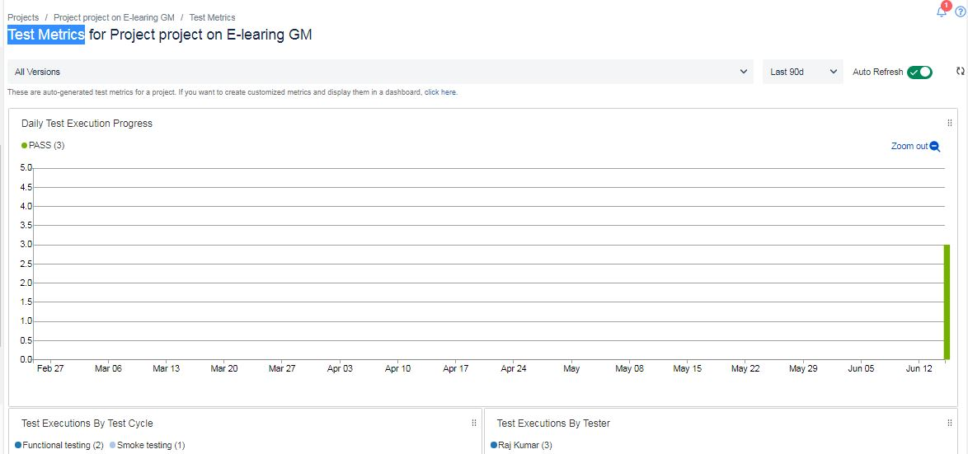

# TEST SUMMARY

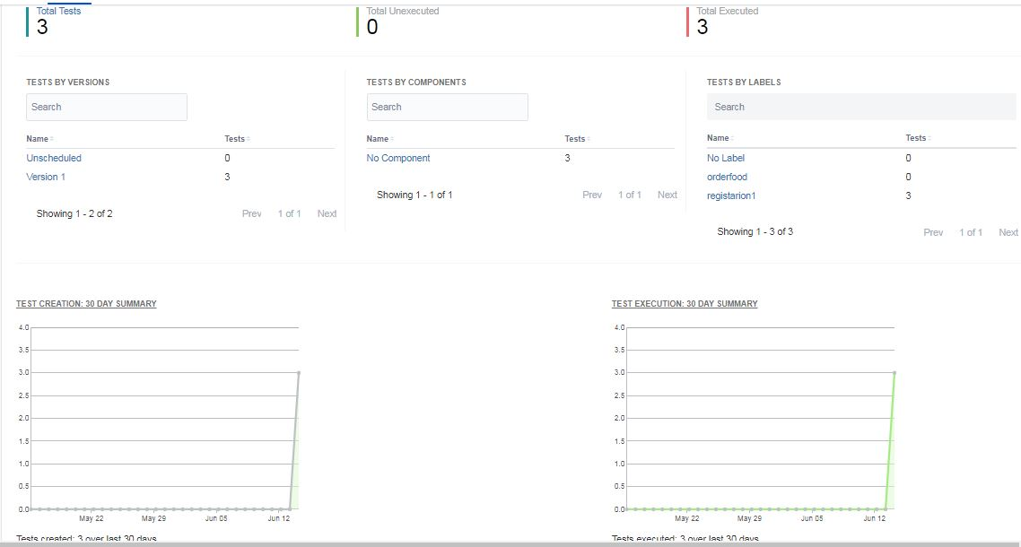

# C:\Users\applecom\Desktop\moolyaa\jeera screenshots\case study on jeera\Reports\Tracability matrix.JPGTRACEBALITY MATRIX